1. Maintain personal information

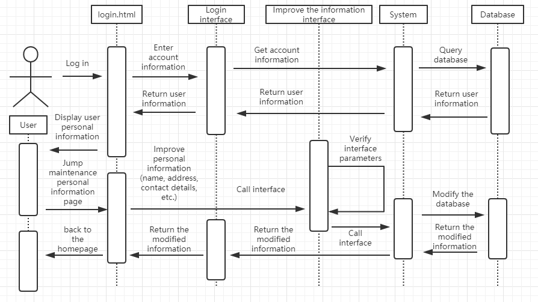

After the user logs in, click the Perfect Personal Information button, and the system will read the stored personal information from the database and display it on the website. Then the user can select the perfect personal information on the corresponding project. After completing the button, the information will be transmitted to the system. If the audit is passed, it will be stored in the database. If the audit fails, the user will refuse to modify and ask the user to re-improve the corresponding information.

2.Payment process

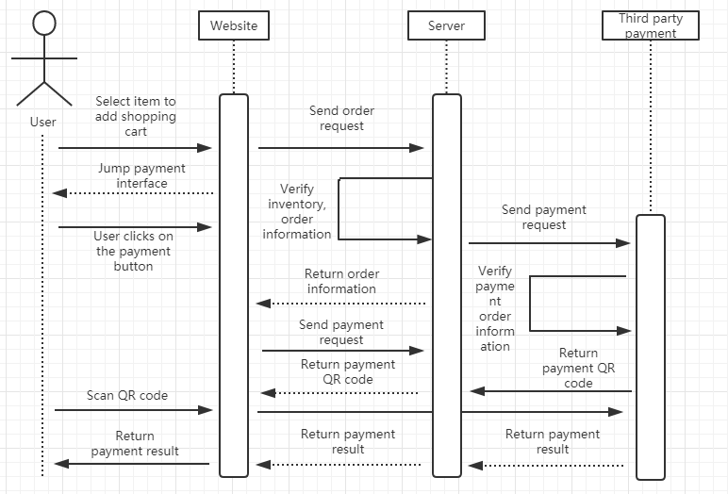

After the user selects the item to be rented, click the rent button to enter the payment interface. This interface will display the product information that the user will purchase, the rental time and the price. After the user confirms, click the confirmation button, and the system will jump into the third-party payment interface (Alipay, WeChat payment) The third-party payment system will then produce a two-dimensional code. After the user scans the mobile phone, the payment is confirmed. The third-party payment system will successfully report the payment to the system. The system will report the payment status to the user through the website.